Swedish Canaries: Erik’s replication of job postings did, 2026-03-10
This document reports Erik’s replication of the difference-in-differences (did) analysis of the impact of monetary tightening, ChatGPT and AI exposure on postings/ads data, as of 2026-03-10.
I focused on the main did result reported in the paper. I have not replicated the robustness analyses.
The main conclusion is that I was able to successfully replicate the results in Stata and with an independently generated postings/ads dataset.
Slightly more detailed conclusions:
- When running through the entire pipeline, generating the datasets and producing results, the mainline result is robust, compared to what is reported in the paper. The negative ChatGPT coefficient becomes slightly larger and now has p<0.1.
  - My new data includes several more weeks of data compared to the result reported in the paper, this could explain the minor difference.
- The postings dataset which is used in the analysis (one obs per SSYK4-year-month, with ad counts) is almost identical to the equivalent data generated by Erik last fall.
- I was able to replicate the main did regression result in several additional ways:
  - In Stata, using the dataset generated by the pipeline.
  - In Stata, using my old dataset.
    - My old dataset is observed only for 2020-2024, so I compared with a Stata-estimation for 2020-2024 using the new data.

Replicating the main posting result
I will focus on replicating the following result from the paper, which is our main result from the postings analysis:
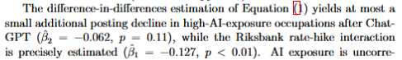

Running the main script locally
I started by running the full repo (through the master script, “run_all.py”), to build the datasets and run the analyses. It was successful, and updated the dataset with data from the last few days.

Replicating the main regression locally
Below are the main regression results outputted by the script (“05_analysis.py”) when I ran it locally, without making any changes.
The key coefficients are identical for Riksbank and very similar for ChatGPT. The ChatGPT coefficient is slightly larger and crosses the line to being weakly statistically significant (it had p = 0.11 before, just on the boundary).
Because the pipeline updates with the latest data, my data contain a few more weeks of data compared to what was likely used to produce the results currently reported in the paper. This could explain some of the (small) difference on the ChatGPT coefficient.
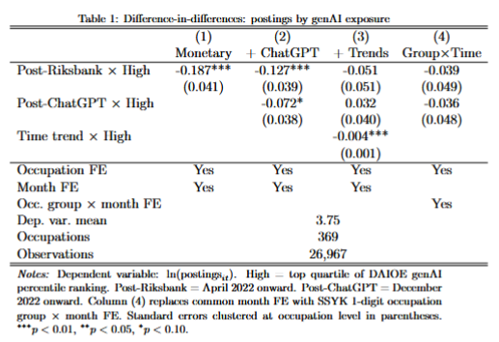

Checking the dataset
The final dataset which is used for the main analysis (“postings_ssyk4_monthly.csv”) contains one observation per SSYK4-year-month, with a variable counting the number of postings/ads.
This is equivalent to the dataset that I created last fall when I was attempting to do a similar did analysis. So to evaluate the new data, I tried merging it with my equivalent data (but only for 2020-2024, as my dataset does not contain data for 2025).
The results below (regression + correlation) show that the number of ads per observation is extremely highly correlated between the two datasets, with R2=99.8.
60 obs did not merge; 59 only observed in Erik data, 1 in Claude data. But compared to about 23400 obs, this only represents 0.3 % of all obs.
I judged that the differences between the two datasets are negligible and did not investigate them further.
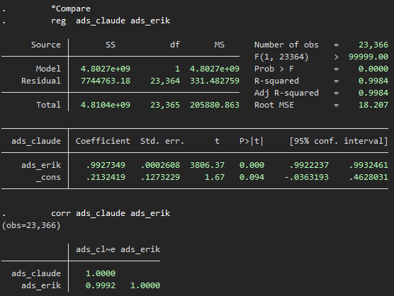

Replicating the main regression result in Stata
I tried to import the same dataset that is used for the analysis (“did_panel.csv”), and replicating the result in Stata, instead of Python. The coefficients replicate exactly.
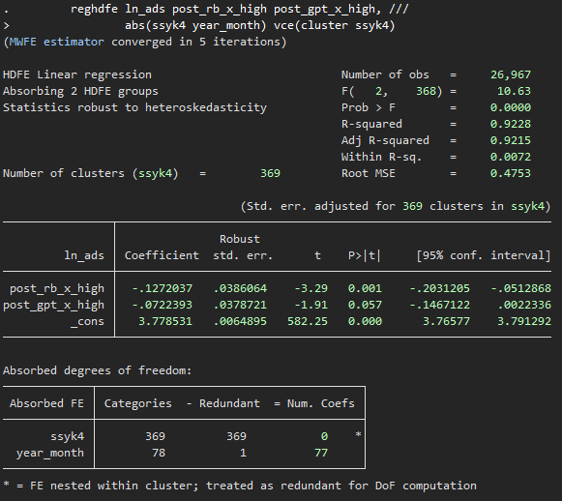

Replicating the main regression result in Stata and with my data
As a final robustness check, I tried to replicate the result with my old dataset.
Since I had already confirmed that my old dataset was virtually identical to the new one, and that I could replicate the regression model in Stata, I expected this result to be robust.
Here is the result estimated on the new dataset, but restricted to the years 2020-2024 to be comparable to my dataset:
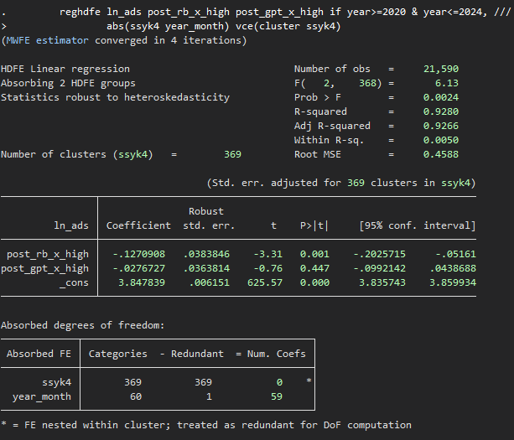
The ChatGPT coefficient becomes smaller when 2025 is excluded.
And here is the result estimated on my old dataset:
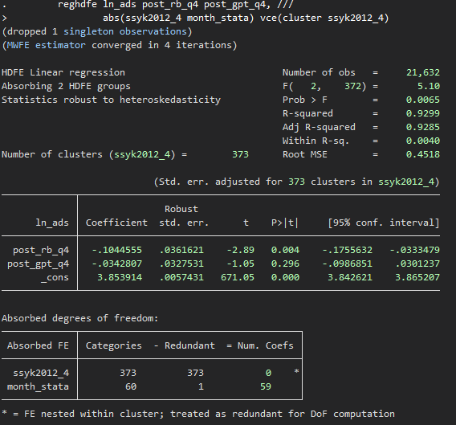
We can see that the results are very similar. Essentially, they are robust.
The small difference could arise due to the fact that the regression on my old dataset contains four more occupations than the new one. As we saw above, my old dataset contains 59 observations not included in the new dataset. I did not investigate further what gives rise to this minor data disparity.

